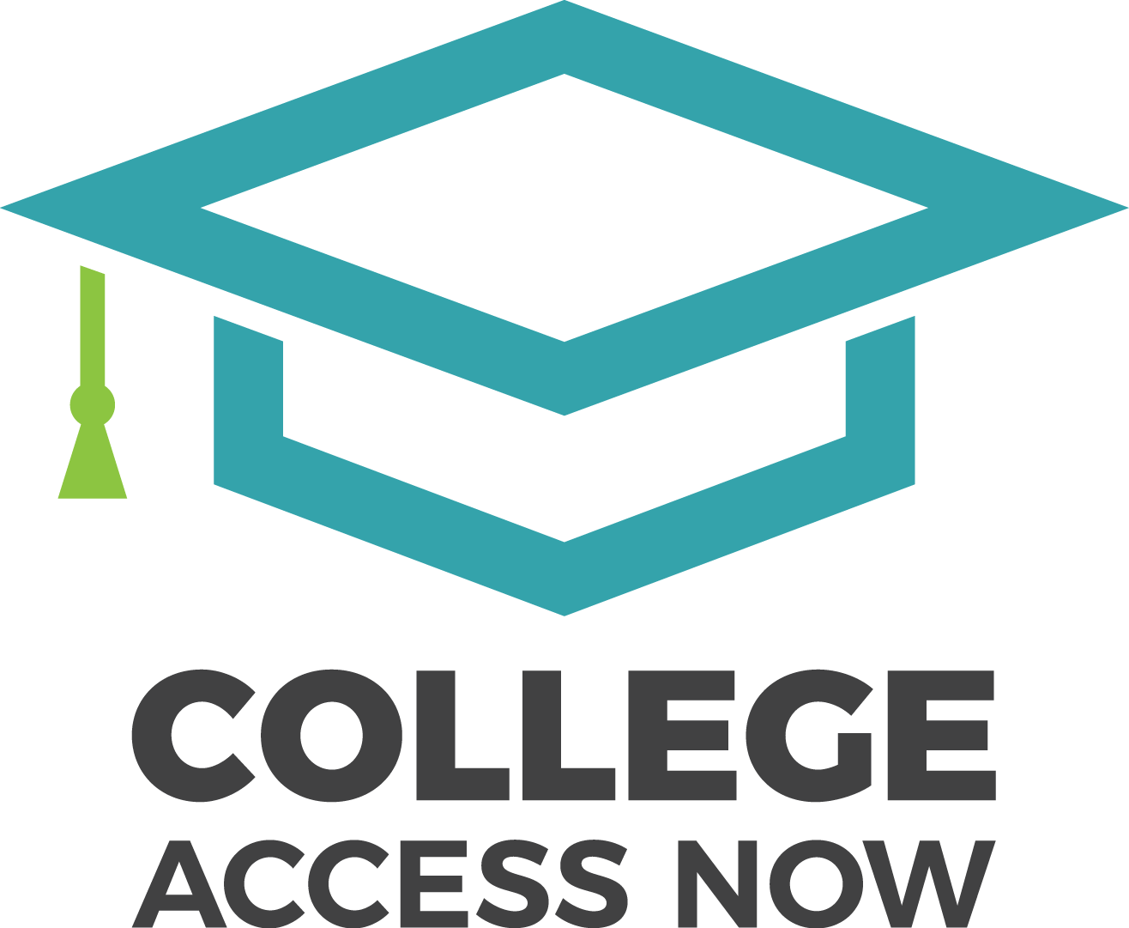
Former College Access Now Executive Director Susan Mitchell Named Interim Executive Director

(Seattle, WA) -- February 8, 2017: The College Access Now (CAN) Board of Directors announced today that former Executive Director Susan Mitchell will assume the position as Interim Executive Director at CAN. Sheri Ranis, Ph.D., CAN Executive Director has submitted her resignation, which was accepted by the Board.
“We are appreciative of Dr. Ranis’ deep knowledge of college access and success programs and wish her well as she returns to her primary areas of interest, including philanthropy, advocacy and policy work,” said Linda Hendrickson, CAN Board Chair. “We are also fortunate to have Susan Mitchell return to the helm as we navigate unprecedented growth in our organization.”
Susan Mitchell will step in as Interim Executive Director, effective immediately. Susan oversaw CAN’s organizational refinement and expansion from 2012 to 2015, ultimately leaving to pursue a lifelong dream of sailing the South Pacific. Since returning from her first significant trip, Susan is building a consulting practice including the provision of interim executive roles. Luckily CAN was able to find her available between consulting roles, as well as between future sailing excursions.
“We appreciate Sheri’s deep knowledge, which she generously shared with CAN over the last year,” said Linda Hendrickson, Board Chair. “Our amazing staff, who spend every day focused on inspiring and supporting CAN students to access and complete college, will continue to do their awesome work. In fact, they are on track to meet our goal of serving 2,200 high school and college students this academic year.”

